# **Grouped Samples**

Students learn about grouped samples, and practice creating them from the Animals Dataset. In the process, they practice using the Design Recipe to create filter functions, and come up with questions they wish to explore.

| **Prerequisites** | [Defining Table Functions](https://bootstrapworld.org/materials/spring2021/en-us/courses/data-science/lessons/ds-defining-table-functions/index.shtml) |
| --- | --- |
| **Relevant Standards** | *Common Core Math Standards*  **6.EE.B.6**  Use variables to represent numbers and write expressions when solving a real-world or mathematical problem; understand that a variable can represent an unknown number, or, depending on the purpose at hand, any number in a specified set.  **8.SP.A.1**  Construct and interpret scatter plots for bivariate measurement data to investigate patterns of association between two quantities. Describe patterns such as clustering, outliers, positive or negative association, linear association, and nonlinear association.  *Next-Gen Science Standards*  **HS-SEP4-5**  Evaluate the impact of new data on a working explanation and/or model of a proposed process or system. |
| **Lesson Goals** | Students will be able to…​   * Make grouped samples from a population |
| **Student-facing Lesson Goals** | * Let’s combine what we know about sampling and filtering with creating displays. |
| **Materials** | * [Lesson slides](https://docs.google.com/presentation/d/1Yw5WhQRkz6F7G0mE6CP9HahgDZt9hdp4khfjnlBrzKQ/) * [Animals Starter File](https://code.pyret.org/editor#share=1ZupMVPWvVUOM0HCWyA7cRBghSLKxPWv1) * [Grouped Samples from the Animals Dataset (Page 41)](https://bootstrapworld.org/materials/spring2021/en-us/courses/data-science/lessons/ds-grouped-samples/pages/samples-from-animals-dataset.html) * [Displaying Data (Page 42)](https://bootstrapworld.org/materials/spring2021/en-us/courses/data-science/lessons/ds-grouped-samples/pages/data-displays2.html) |
| **Preparation** | * Make sure all materials have been gathered * Decide how students will be grouped in pairs * Computer for each student (or pair), with access to the internet * [Student workbook](https://bootstrapworld.org/materials/spring2021/en-us/courses/data-science//workbook/workbook.pdf), and something to write with * All students should log into [CPO](https://code.pyret.org/) and open the "Animals Starter File" they saved from the prior lesson. If they don’t have the file, they can [open a new one](https://code.pyret.org/editor#share=1ZupMVPWvVUOM0HCWyA7cRBghSLKxPWv1) |
| **Language Table** | | Types | Functions | Values | | --- | --- | --- | | **Number** | num-sqrt, num-sqr | 4, -1.2, 2/3 | | **String** | string-repeat, string-contains | "hello", "91" | | **Boolean** | ==, <, <=, >=, string-equal | true, false | | **Image** | triangle, circle, star, rectangle, ellipse, square, text, overlay, bar-chart, pie-chart, bar-chart-summarized, pie-chart-summarized | 🔵🔺🔶 | | **Table** | count, .row-n, .order-by, .filter, .build-column |  | |

***Glossary***

**grouped sample** a non-random subset of individuals chosen from a larger set, where the individuals belong to a specific group

## Problems with a Single Population

## 10 minutes

### *Overview*

This activity is all about ***grouped samples***: Students make a bunch of subsets from the Animals Dataset, and see how each subset might answer the same question differently.

### *Launch*

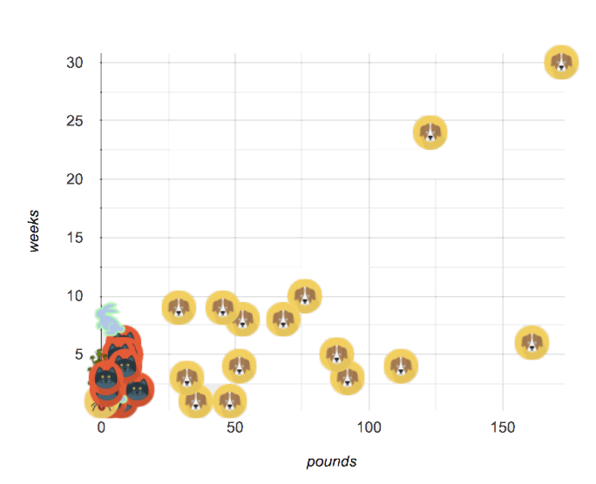When looking at a scatter plot of our animals, it looks like the amount an animal weighs may have something to do with how long it takes to be adopted.

But if we label the dots by animal (see the image on the right), we notice *every data point* after 25 pounds belongs to a dog from the shelter! The cats are all clumped together in the lower weight range, making it hard to see how weeks to adoption may relate to a cat’s weight.

### *Investigate*

Divide the class into groups of 3-4, with one student identified as the "reporter".

* Looking at this scatterplot, does it make sense to analyze all the animals together? Why or why not?
* Are there some questions where it would be important to break up the population into species-specific populations? What are they?
* Are there some questions where it would be important to keep the whole population together? What are they?

### *Synthesize*

Have the reporters share their findings with the class.

Imagine that you’ve been handed a dataset from a country where half the people are wealthy and have access to amazing medical care, and the other half are poor and have no healthcare. If we took a random sample of the population as a whole, we might think that they are generally middle-income and have average health. But if we ask the same question about the two groups *separately*, we would discover inequality hiding in plain sight!

## Grouped Samples

## 20 minutes

### *Launch*

Ultimately, it might make more sense to ask certain questions about "just the cats" or "just the dogs". Averaging every animal together will give us an answer, but it may not be a *useful* answer.

Sometimes important facts about samples get *lost* if we mix them with the rest of the population!

Data Scientists make ***grouped samples*** of datasets, breaking them up into sub-groups that may be helpful in their analysis.

### *Investigate*

A “kitten” is an animal who *is a cat* and who *is young*. How would you make a subset of just kittens?

* Turn to [Grouped Samples from the Animals Dataset (Page 41)](https://bootstrapworld.org/materials/spring2021/en-us/courses/data-science/lessons/ds-grouped-samples/pages/samples-from-animals-dataset.html), and see what code will compute whether or not an animal is a kitten.
* Can you fill in the code for the other subsets?
* When you’re done, type these definitions into the Definitions Area.

We already know how to define values, and how to filter a dataset. So let’s put those skills together to define one of our subsets:

dogs = animals-table.filter(is-dog)

* Define the other subsets, and click "Run".
* Make a pie chart showing the species in the young subset, by typing pie-chart(young, "species").
* Make pie charts for every grouped sample. Which one is the most representative of the whole population? Why?

### *Synthesize*

Debrief with students. Thoughtful question: how could we filter *and* sort a table? How can we combine methods?

## Displaying Samples

## 20 minutes

### *Overview*

Students revisit the data display activity, now using the samples they created.

### *Launch*

Making grouped and random samples is a powerful skill to have, which allows us to dig deeper than just making charts or asking questions about a whole dataset. Now that we know how to make subsets, we can make much more sophisticated displays!

### *Investigate*

Complete [Displaying Data (Page 42)](https://bootstrapworld.org/materials/spring2021/en-us/courses/data-science/lessons/ds-grouped-samples/pages/data-displays2.html), using what you’ve learned about samples to make more sophisticated data displays.

### *Synthesize*

Were any of the students' displays interesting or surprising? Given a novel question, can students identify what helper functions they would need to write?